Devops Fundamentals:

DevOps is defined as improvement in Existing-system

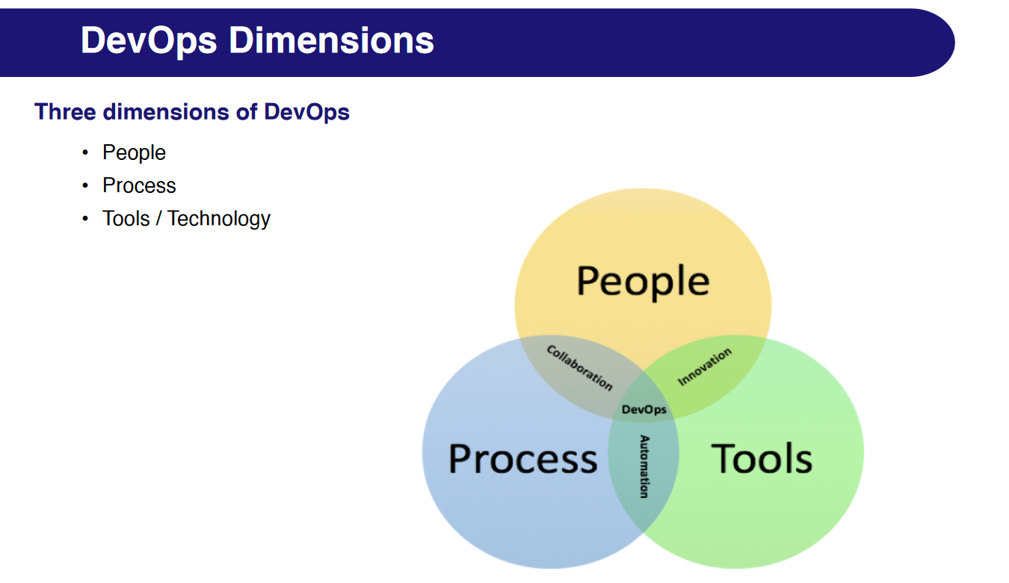

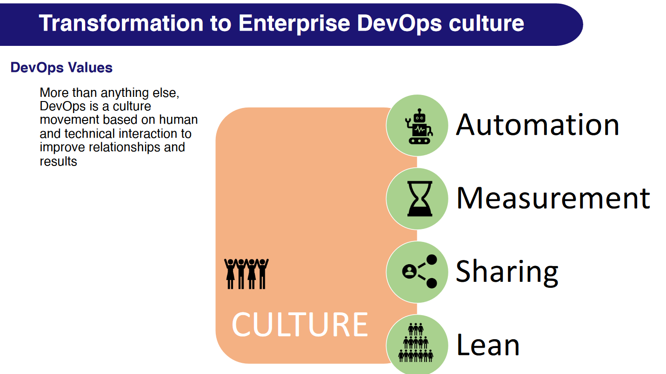

Patrick Debois [Father of Devops]

The origins of the DevOps trace back to when the term, “DevOps” was first coined by Patrick Debois in 2009 which is regarded as the DevOps origin year.  
  
What is Devops as per Patrick Debois: [Video](https://www.youtube.com/watch?v=5VqXqtL0xQI&t=17s)  
  
Design Thinking: [Video](https://www.youtube.com/watch?v=_r0VX-aU_T8&t=18s)

* Empathize: research your users' needs.
* Define: state your users' needs and problems.
* Ideate: challenge assumptions and create ideas.
* Prototype: start to create solutions.
* Test: try your solutions out.

Document:  [Documents](https://github.com/2020ht66049/Documents/blob/main/NOTES1_WC_Devops-SDLC-AGILE-DEVOPS-Introduction.pdf)

Measuring Devops Success:  [Link](https://github.com/2020ht66049/Documents/blob/main/Measuring%20DevOps%20Success%20and%20KPI_%20Unlocking%20Business%20Value(1).pdf)

Evolution in industry:

1) Bank withdrawal [Manual > ATM > Digital wallet]

2) Messaging [Postcard > Mobile-call > Digital message]

3) Traveling [By-ship > by-flight [high cost]> by-flight[low-cost]]

SDLC: SDLC stands for Software Development Life Cycle which is defines step by step process to develop software.

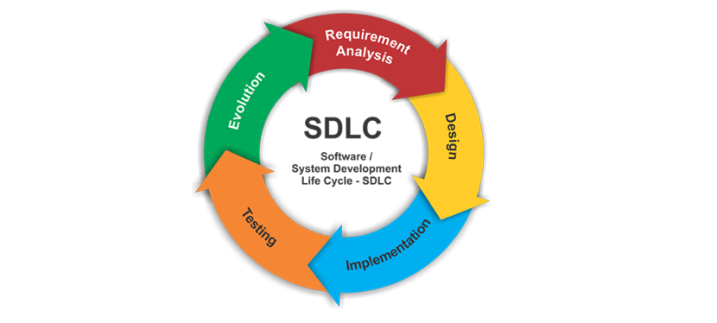

PPT for reference: [Link](https://github.com/2020ht66049/Documents/blob/main/Devops%20Class-1.pptx)